NVQ L2 Front of House Reception – Induction Activity
Welcome to the NVQ L2 Diploma in Front of House Reception, we look forward to you joining the course.
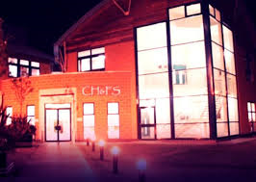
The hospitality industry covers a huge range of businesses from cafes to bars and restaurants, Health spas and gyms, B&Bs to 5 star hotels, concerts and festivals, career and travel prospects are vast – from London to Sydney, the sky really is the limit! You could work in a reception area, in an NHS or private hospital, at a fitness centre or gym, in an office or in a hotel.

Skills and knowledge you will need to be a Receptionist:
- the ability to work well with others
- to be thorough and pay attention to detail
- administration skills
- patience and the ability to remain calm in stressful situations
- the ability to accept criticism and work well under pressure
- sensitivity and understanding
- customer service skills
- excellent verbal communication skills
- to be able to carry out basic tasks on a computer or hand-held device
Your day-to-day tasks may include:
- greeting visitors and directing them to the correct person or department
- answering enquiries in person, by phone and email
- managing a room booking system and keeping reception areas tidy
- dealing with incoming and outgoing post and deliveries
- arranging appointments and updating records on databases
- taking payments and handling invoices
Research Task
- Hotel ratings are used to classify hotels and make guests aware of the service and facilities to expect. Stars are awarded by the Automobile Association (AA) grades are awarded from 1 to 5.
- Research and list what a guest would expect from each rating (1 to 5)
- Find two hotels in the UK from each rating – one in the country and one in a city of your choice.
- How much do they charge for a 1 night stay on Saturday 24th October 2020?
- Is there a difference in price? Why do you think this is?

